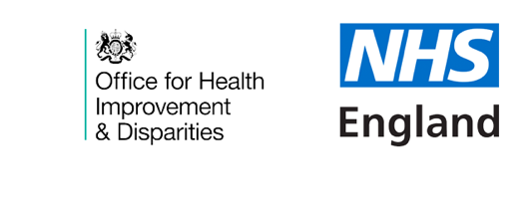
Save The Date
18th May from 1pm until 4pm
Delivering CVD Prevention and Recovery in the North West
“To address Health Inequalities and Save Lives”
Amanda Doyle, Andrew Furber and David Levy
Would like to cordially invite you to save the date for this collaborative event to support innovation and strengthen partnership working around CVD Prevention and Recovery across the North West.
The day will feature an excellent mix of national and regional speakers as well as opportunities for discussion to inform and support a call to action across region, system, place, and neighborhoods.
The aims of the event include:
- Enable systems to develop their CVD prevention recovery plans which will reduce inequalities and save lives – through primary secondary and tertiary prevention
- Understanding CVD recovery landscapes and opportunities to align programmes within systems and, where appropriate, across the North West
- Facilitating discussion around CVD multidisciplinary system leadership across the three North West ICS footprints to support the detection and management of CVD risk factors.
Who should attend?
We are asking for leaders and decision makers from the wider health and social care system to be represented at the event to include representation from NHS, ICS, Local Authority, third sector, pharmacy, community services, AHSN and academic institutions.
Booking Link
Delivering CVD Prevention and Recovery in the North West - Registration Form

Background
The pandemic has shown us that Cardiovascular disease (CVD) and COVID-19 share common underlying risk factors and the North West has been hit hard by both.
They both disproportionately affect the most deprived communities. CVD is the largest contributor to the gap in life expectancy between the most and least deprived, accounting for up to 25% of the difference. Data also shows that premature CVD mortality is four times higher in the most deprived communities.
CVD national ambitions and the NHS Long Term Plan committed to prevent 150,000 heart attack and strokes over the next 10 years and remain vital to recovery and restoration. Independent PHE estimates show that if the ambitions were achieved within 3 years, at least 49,000 strokes and 32,000 heart attacks could be prevented. https://cvd-prevention.shef.ac.uk/ across England? Across UK?
In the North West as we move in to Covid recovery, we are beginning to see the impact of delayed access to the management of risk factors and the pause in CVD prevention programmes. National and regional data show an excess of mortality from CVD and Diabetes which requires urgent action.
Discussion with stakeholders has suggested that CVD prevention is a busy space with much great work but at times with insufficient co-ordination. As we recover and reset services, there is an opportunity and need to avoid duplication of efforts, simplify key messages, and rationalise actions.
This event proposes a regionally hosted leadership round table on CVD prevention which will include:
- Primary care: early detection and optimal management of blood pressure, lipids, and atrial fibrillation
- Long term plan: CVD prevention in other health settings including tobacco and alcohol support services in secondary care
- Local government and third sector: Public health commissioned services such as health checks and MECC which can support CVD prevention and wider prevention initiatives
The learning from the Covid19 pandemic has included greater partnership working and collaboration, accelerated the use of technology and opened opportunities for making better use of data.
Building on this approach, there is an opportunity to align recovery plans for CVD prevention across the integrated care systems to ensure healthcare restoration is equitable but maximising the digital and data opportunities- as well as recognising the need for wider partners to be part of solutions.

